Plant Calculation

Assuming: all of the carbon dioxide in a plant is absorbed during the carbon cycle, which results in the growth of the plant. A typical plant consist of 58% organic matter, more specifically carbon ([source](http://www.alternet.org/story/10050/the_global_citizen%3A_how_much_greenhouse_gas_does_your_garden_cut))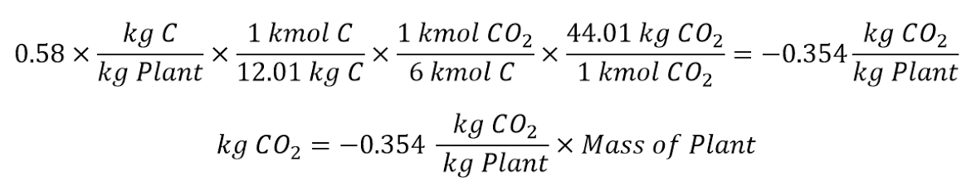

The carbon content must be converted into CO2 content by using the photosynthesis reaction: 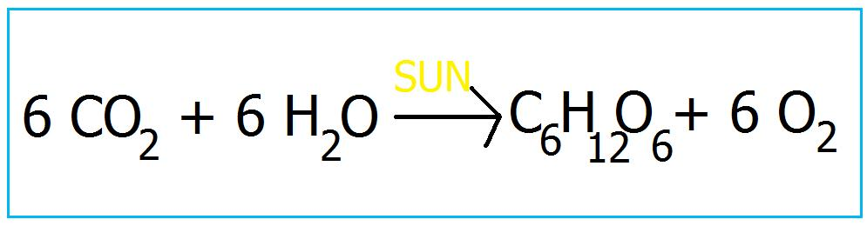

This assumes 6 moles of carbon dioxide is consumed to create 1 mole of glucose.